Electromagnetic Field and Power Flow Analysis of a
Rectangular Waveguide in CST Studio Suite and determination of S parameters.
Test Case 1:
To simulate a Rectangular Waveguide using CST Studio Suite, analyze its electromagnetic behaviour, and examine the power distribution among ports over a specified frequency range.
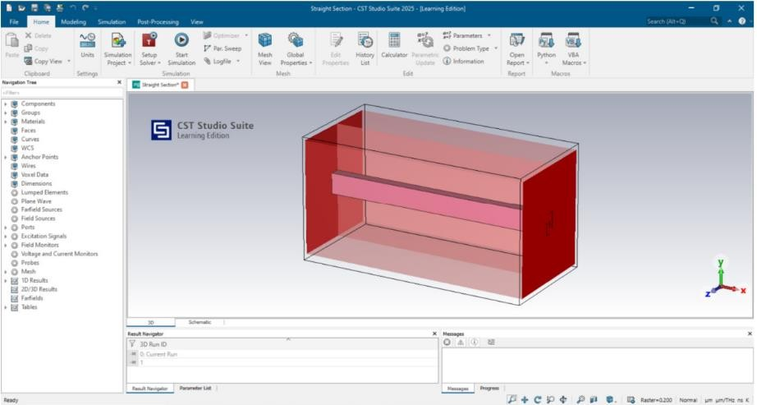
c
Output:
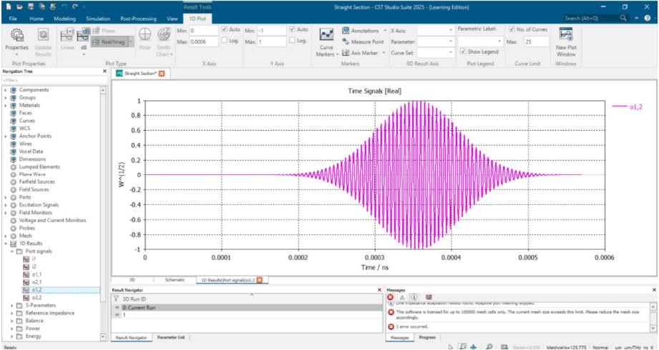
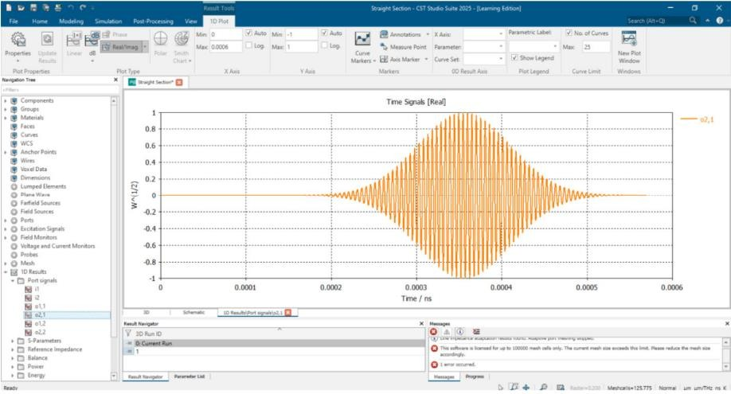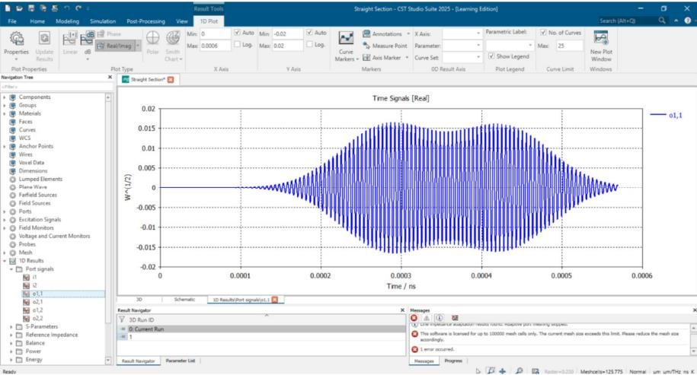
Test Case 2:
To simulate a Rectangular Waveguide using CST Studio Suite, analyze its electromagnetic behaviour, and examine the S parameters.

Output:
